ST. XAVIER’S COLLEGE

**(Affiliated to Tribhuvan University)**

**Maitighar, Kathmandu**



**Computer Graphics**

**Lab Assignment #8**

**SUBMITTED BY**

**PRANESH DHUNJU SHRESTHA**

**013BSCCSIT026**

**4th sem/ 2nd year**

**SUBMITTED TO**

**Er. Anil K Sah**

**Lecturer**

**Department of Computer Science**

**St. Xavier’s College**

**STATEMENT :**

2-D REFLECTION

**SOURCE CODE :**

//---------------------------------------------------------------------------

#include <vcl\vcl.h>

#pragma hdrstop

#include "Unit1.h"

//---------------------------------------------------------------------------

#pragma resource "*.dfm"

TForm1 *Form1;

int x,y,a,b,i,j;

//---------------------------------------------------------------------------

__fastcall TForm1::TForm1(TComponent* Owner)

: TForm(Owner)

{

}

//---------------------------------------------------------------------------

//---------REFLECTION ABOUT X-AXIS

void __fastcall TForm1::Button1Click(TObject *Sender)

{

x=Image1->Height;

y=Image1->Width;

for (i=0;i<=x;i++)

{

for (j=0;j<=y;j++)

{

a=i;

b=-j;

b=b+y;

Image2->Canvas->Pixels[a][b]=Image1->Canvas->Pixels[i][j];

}

}

}

//---------------------------------------------------------------------------

//---------REFLECTION ABOUT Y-AXIS

void __fastcall TForm1::Button2Click(TObject *Sender)

{

x=Image1->Height;

y=Image1->Width;

for (i=0;i<=x;i++)

{

for (j=0;j<=y;j++)

{

a=-i;

b=j;

a=a+x;

Image2->Canvas->Pixels[a][b]=Image1->Canvas->Pixels[i][j];

}

}

}

//---------------------------------------------------------------------------

//---------REFLECTION ABOUT ORIGIN

void __fastcall TForm1::Button3Click(TObject *Sender)

{

x=Image1->Height;

y=Image1->Width;

for (i=0;i<=x;i++)

{

for (j=0;j<=y;j++)

{

a=-i;

b=-j;

a=a+x;

b=b+y;

Image2->Canvas->Pixels[a][b]=Image1->Canvas->Pixels[i][j];

}

}

}

//------------------------------------------------------

**OUTPUT :**

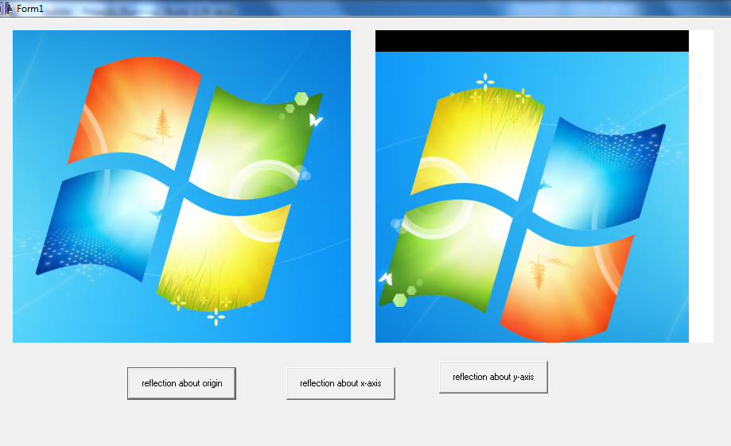

FIG : REFLECTION ABOUT ORIGIN

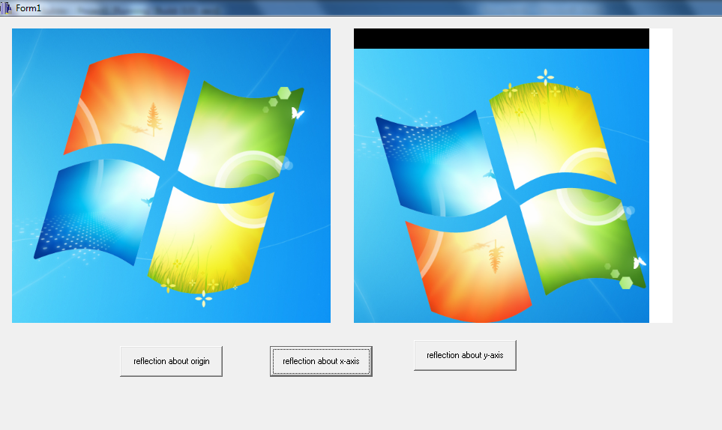

FIG : REFLECTION ABOUT X-AXIS

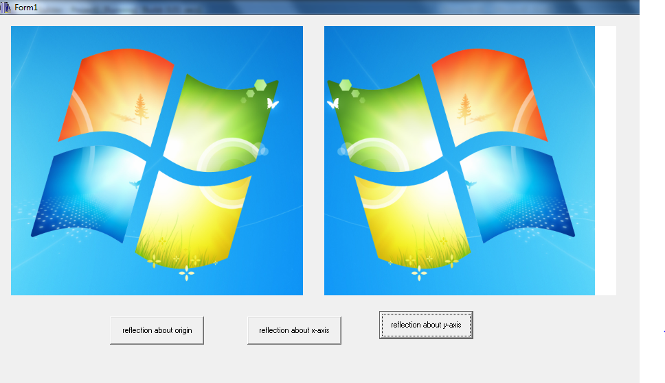

FIG : REFLECTION ABOUT Y-AXIS